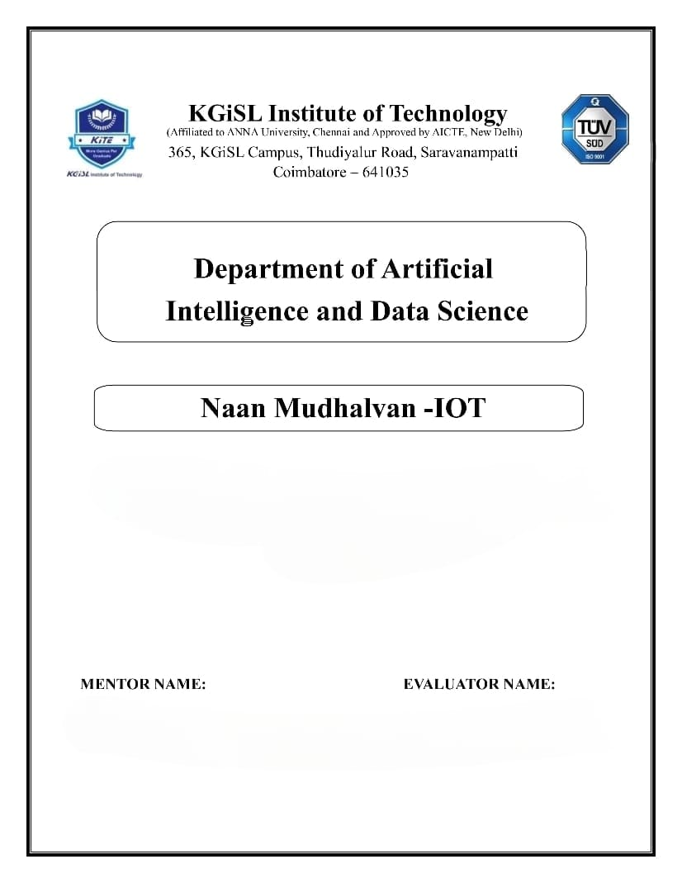

**PROBLEM STATEMENT : PUBLIC TRANSPORT OPTIMIZATION**

Mr.MOHANKUMAR.M

Ms.AKILANDESWARI.M

**Problem Statement:**

We’re addressing the issue of the public transportation system in a major metropolitan area is facing numerous challenges, including inefficiency, overcrowding, and poor service reliability. To address these issues and improve the overall quality of public transportation services, a comprehensive optimization project is needed.

**Solution:**

To optimize public transport in [City Name], the project will focus on route optimization, schedule consistency, and technology integration. By redesigning routes to minimize travel time, reducing overcrowding through fleet expansion, and ensuring a more reliable timetable, passengers will experience a smoother and more efficient commute. Introducing modern ticketing systems, real-time tracking, and a platform for passenger feedback will enhance the overall user experience, making public transport more accessible and attractive. Sustainability measures like the adoption of eco-friendly vehicles and data-driven decision-making will help reduce the system's environmental impact and continually adapt to evolving passenger needs. This comprehensive approach aims to transform public transport into a more convenient, eco-friendly, and customer-centric mode of transportation in.

**Objectives:**

The primary objective of this public transport optimization project in [City Name] is to create a more efficient, reliable, and user-friendly public transportation system. This project seeks to reduce overcrowding, improve schedule consistency, and enhance route planning to provide passengers with a more comfortable and convenient commuting experience. By implementing modern technology solutions and sustainability measures, we aim to encourage increased ridership and reduce the environmental impact of the public transport system. Ultimately, our goal is to contribute to a more sustainable and livable city while promoting the use of public transportation as a preferred mode of commuting.

**IoT device setup:**

1. Vehicle Tracking: Equip public transport vehicles with GPS and IoT sensors to track their real-time locations. This data can be used to update schedules, provide accurate arrival times to passengers, and optimize routes for efficiency.

2. Passenger Information Systems: Install displays or mobile apps at bus stops and train stations that provide real-time information on vehicle locations, expected arrival times, and route updates, enabling passengers to plan their journeys more effectively.

3. Passenger Counting: Use IoT sensors to monitor passenger counts in vehicles, helping to prevent overcrowding and ensure passenger comfort. This data can be used to adjust fleet deployment as needed.

4. Environmental Monitoring: Employ IoT sensors to monitor vehicle emissions, air quality, and noise levels. This data can be used to assess the environmental impact of the public transport system and make improvements.

5. Ticketing and Payment: Implement contactless IoT-enabled ticketing and payment systems, allowing passengers to pay via mobile apps, smart cards, or other digital means for a seamless and cashless experience.

6. Maintenance and Diagnostics: Outfit vehicles with IoT sensors that monitor their condition in real-time. This data can help schedule maintenance, reduce breakdowns, and extend the lifespan of vehicles.

7. Passenger Feedback: Develop IoT-enabled feedback mechanisms that allow passengers to report issues, provide suggestions, or rate their experience, helping authorities make informed decisions for service improvements.

8. Traffic Management: Integrate IoT data into traffic management systems to reduce congestion and improve traffic flow, making public transport a more efficient and reliable option.

9. Energy Efficiency: Implement IoT solutions to optimize energy consumption in public transport operations, such as turning off heating/cooling systems in empty vehicles and reducing overall energy waste.

10. Security and Surveillance: Install IoT-enabled security cameras and surveillance systems to ensure the safety of passengers and prevent vandalism or other security concerns.

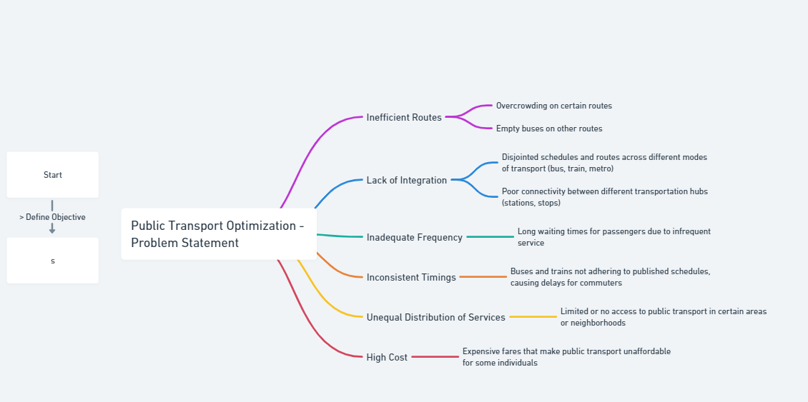

**Platform development :**

1. Data Analytics: Incorporate data analytics tools to gain insights from collected data, allowing for informed decision-making and continuous system improvement.

2. IoT Device Management: Develop a system for monitoring and managing IoT devices on vehicles, at stops, and within stations, ensuring their proper functioning and maintenance.

3. Payment and Ticketing: Enable contactless payment and digital ticketing options, ensuring secure and convenient transactions.

4. Communication Systems: Implement communication channels for real-time notifications, alerts, and emergency responses to enhance passenger safety and satisfaction.

5. Reporting and Feedback: Create dashboards for reporting key performance metrics and collecting passenger feedback to address issues promptly.

6. Security and Privacy: Implement robust security measures to protect passenger data and ensure the integrity and availability of the platform.

7. Scalability: Design the platform to be scalable to accommodate future growth and evolving requirements of the public transport system.

8. Cloud Infrastructure: Consider hosting the platform on a reliable cloud infrastructure to ensure scalability, availability, and data redundancy.

9. Integration with Other Systems: Integrate the platform with existing traffic management systems, city databases, and other relevant infrastructure for seamless operation.

10. Sustainability Integration: Include features to monitor and optimize energy consumption, aligning with sustainability goals.

**Project Requirements:**

A. **GPS Sensors:**

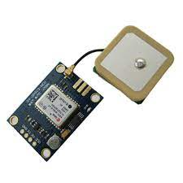

B. **Traffic Flow Sensors:**

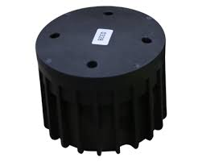

**Circuit diagram:**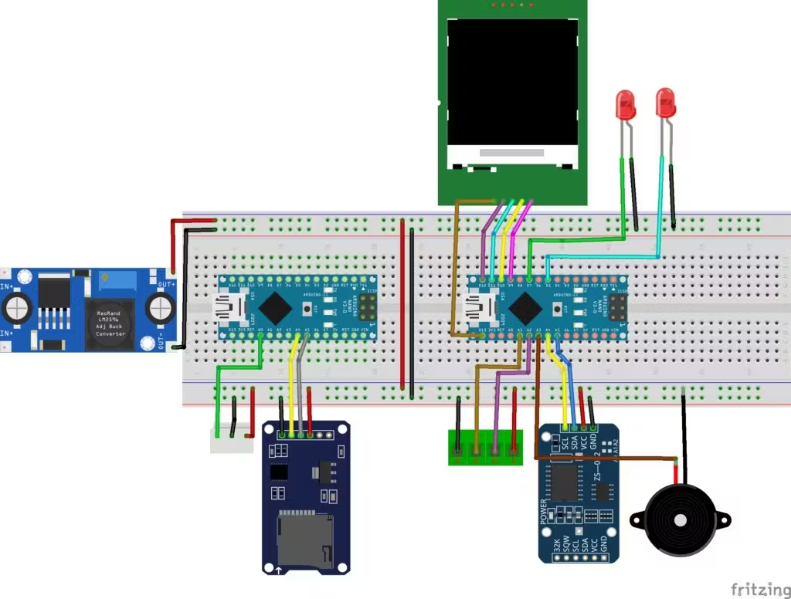

**Code implementation:**

**https://github.com/karthikeyan6374/naanmudhalvan/blob/main/code**

**SOURCE CODE:**

import logging

import confluent_kafka

from confluent_kafka import Consumer

from confluent_kafka.avro import AvroConsumer

from confluent_kafka.avro.serializer import SerializerError

from tornado import gen

logger = logging.getLogger(__name__)

class KafkaConsumer:

"""Defines the base kafka consumer class"""

def __init__(

self,

topic_name_pattern,

message_handler,

is_avro=True,

offset_earliest=False,

sleep_secs=1.0,

consume_timeout=0.1,

):

"""Creates a consumer object for asynchronous use"""

self.topic_name_pattern = topic_name_pattern

self.message_handler = message_handler

self.sleep_secs = sleep_secs

self.consume_timeout = consume_timeout

self.offset_earliest = offset_earliest

self.broker_properties = {

'bootstrap.servers': 'PLAINTEXT://localhost:9094',

'default.topic.config': {'auto.offset.reset': 'earliest'},

'group.id': topic_name_pattern

}

if is_avro is True:

self.broker_properties["schema.registry.url"] = "http://localhost:8081"

self.consumer = AvroConsumer(self.broker_properties)

else:

self.consumer = Consumer(self.broker_properties)

pass

self.consumer.subscribe([topic_name_pattern],on_assign=self.on_assign)

def on_assign(self, consumer, partitions):

"""Callback for when topic assignment takes place"""

for p in partitions:

consumer.seek(p)

logger.info(f"partitions assigned for {self.topic_name_pattern}")

consumer.assign(partitions)

async def consume(self):

"""Asynchronously consumes data from kafka topic"""

while True:

num_results = 1

while num_results > 0:

num_results = self._consume()

await gen.sleep(self.sleep_secs)

def _consume(self):

"""Polls for a message. Returns 1 if a message was received, 0 otherwise"""

try:

msg = self.consumer.poll(timeout=1.0)

if msg is not None:

if msg.error() is not None:

self.message_handler(msg)

return 1

else:

logger.error(msg.error())

return 0

else:

logger.debug("no message")

return 0

except SerializerError as error:

logger.error(f"Error consuming data: {error.message}")

return 0

def close(self):

self.consumer.close()

/* Basic styling for the webpage */

body {

font-family: Arial, sans-serif;

}

header {

background-color: #0074D9;

color: #fff;

padding: 10px;

text-align: center;

}

main {

display: flex;

justify-content: space-around;

padding: 20px;

}

.map {

width: 60%;

border: 1px solid #ccc;

padding: 10px;

}

#map {

width: 100%;

height: 400px;

}

.info {

width: 35%;

border: 1px solid #ccc;

padding: 10px;

}

h2 {

font-size: 1.2em;

margin-bottom: 10px;

}

**public awareness about public transport optimization:**

1. Information Campaigns: Launch a comprehensive information campaign through various media channels, including TV, radio, newspapers, and social media.

2. Community Engagement: Organize town hall meetings, workshops, and public forums to actively involve residents and gather their input.

3. Mobile Apps and Websites: Develop user-friendly mobile apps and websites that provide project updates, real-time information, and a platform for feedback.

4. Educational Materials: Distribute brochures, pamphlets, and educational materials at public transport stops and stations.

5. Social Media Outreach: Maintain an active presence on social media platforms to provide regular project updates and address public concerns.

6. Public Demonstrations: Organize live demonstrations or exhibitions to showcase the project's benefits and innovations.

7. Partnerships: Collaborate with local businesses, schools, and community organizations to promote the project and engage a broader audience.